AMAZON S3 – REPLICATION (CRR & SRR)
- Must enable Versioning in source and destination buckets
- Cross-Region Replication (CRR)
- Same Region Replication (SRR)
- Buckets can be in different AWS accounts
- Copying is asynchronous
- Must give proper IAM permission to S3
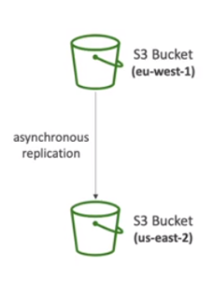
- Use cases:
- CRR: Compliance, lower latency access, replication across accounts
- SRR: log aggregation, live replication between production and test accounts

NOTE: Replication only works if versioning is enabled

HANDS-ON
- Create a premier/original bucket (bucket1) in a region and a secondary/replica bucket (bucket 2) in another region
- Make sure the versioning is enabled on both the buckets
- Add file(s) to the original bucket
- Navigate to the Management tab of the original bucket and create a Replication Rule. Fill the details – the other bucket details
- Create a new IAM role if required

